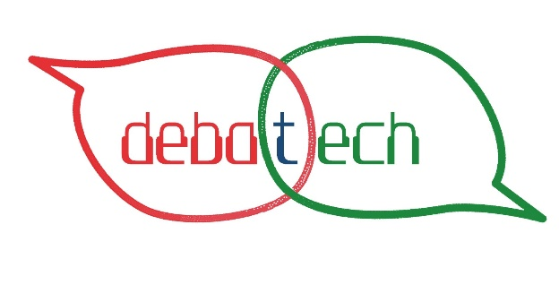


DEBATECH
Project details:
EC Project Number: 2021-1-IT02-KA210-ADU-000034903
Project title: DEBATECH
Coordinator Organisation Legal Name: APS Brainery Academy

“Funded by the European Union. Views and opinions expressed are however those
of the author(s) only and do not necessarily reflect those of the European Union or the European
Education and Culture Executive Agency (EACEA). Neither the European Union nor EACEA can be
held responsible for them.”;

“The European Commission support for the production of this publication does not constitute an endorsement of the contents which reflects the views only of the authors, and the Commission cannot be held responsible for any use which may be made of the information contained therein”

SECOND SESSION - FILE

2. EUROPEAN UNION enhanced people and countries.
THOUGHTS:
- Why & When was the European Union created?
- Do citizens trust this Institution?
- How do citizens perceive it?
- Should Europe become more national or more European?
- Should people continue to move freely or should this freedom be restricted?
- Is it really easy for people to move from one country to another one? Is it easy to settle in a new country?
- Should the internet be free (ex. Western countries) or state controlled (like in China)?
- Shouldn’t we be free to travel/work/live were we desire?

DEBATE:
 | PROs | CONs
1 | Works to guarantee peace (2012 Nobel Prize for PEACE) | Still wars and “disputes”
2 | Promotes economic and social progress. | No relevant improvements from before in Italy
3 | Speaks for the European Union countries on the International scene.  To be more powerful Internationally | The real powerful countries still do and decide for others (from what citizens perceive) – USA/CHINA/RUSSIA
4 | Europe is now a free area where people and goods can circulate freely. No boundaries (economic/social/linguistic/cultural) nor borders (physical limit) / Introduced and, now, develops “EUROPEAN CITIZENSHIP” | Is it easy to feel “European Citizen” when leaving in a European country (if not your native one)?
5 | Provides DEMOCRATIC security | Strong countries (Germany…) are stronger than the other countries / EU favored some countries
6 | Develops Europe as an area of freedom, security and justice. | From the news there were not significant changes related to freedom, security nor justice
7 | Maintains and establishes common EU laws and regulations. | Many countries do not accept the common rules and decisions (the use of the € is not common)
8 | During crisis the EU members work together to find common solutions | The solutions valid in France might not be good/appropriate for Italy (for example)
9 | Many funds are given to try to improve culture, travelling, sense of citizenship.  (ERASMUS PROJECTS) | A limited amount of people are involved in these projects
10 | Promotes the local identities, the National cultures and the historical heritage of each country part of the Union | Many cultural aspects and peculiarities of the countries may be erased or lost.
10 |  | Only “rich” countries are entitled to enter the Union.

SITES:
https://www.citizensinformation.ie/en/government_in_ireland/european_government/european_union/european_union.html
https://culturalfoundation.eu/stories/keeping-up-the-big-debate-about-europe/
http://news.bbc.co.uk/cbbcnews/hi/find_out/guides/european_union/newsid_2139000/2139071.stm
https://www.semantic-web-journal.net/system/files/swj1300.pdf

VIDEOS:
https://www.youtube.com/watch?v=9eufLQ3sew0
https://www.youtube.com/watch?v=gE39L48QzbA
https://www.youtube.com/watch?v=4VCYHTGjr-U
https://www.youtube.com/watch?v=O37yJBFRrfg
https://www.youtube.com/watch?v=aN8Kd7hxCZI
https://www.youtube.com/watch?v=aiqeKFm0cOo
https://www.youtube.com/watch?v=xRJZWfqWcs0

